Phys Ed

**The Best Foods for Athletes**

More fat? More carbs? How should we eat for peak athletic performance?

CreditGetty Images

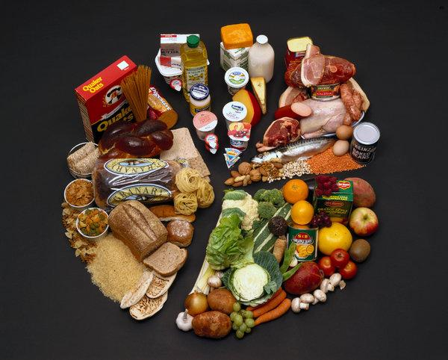

Image

CreditCreditGetty Images

By [Gretchen Reynolds](https://www.nytimes.com/by/gretchen-reynolds)

* Nov. 28, 2018

More fat? More carbs? What kind? How much? When?

Questions about what constitutes an ideal and practical diet for competitive athletes consume and confuse many athletes, as well as their coaches and families. But a new, comprehensive review about the science of sports nutrition [published recently in Science](http://science.sciencemag.org/content/362/6416/781) provides a lucid overview of what currently is known — and not known — about how athletes should eat.

To find out more about these and other topics, I spoke with Louise Burke, a sports dietitian and professor at Australian Catholic University who has worked with many elite Australian sports teams. She wrote the new review with her husband John Hawley, the director of the Mary MacKillop Institute for Health Research at Australian Catholic University. What follows are edited and summarized excerpts from our conversation.